Michael Clark · Matthew Bjorkman · Andrew Wolfe · Christian Bastian · Matthew Gilleland · Simon Pollayil

Technical Documentation
Aetherfall by Meteorstorm Interactive

The Unity based game Aetherfall, developed by the members of Meteorstorm Interactive consists of a menu scene, a galactic hub scene, and a ground combat scene. The main menu scene allows for starting a new game as well as the display of credits. The galaxy scene offers a high level view of the players progress in the game as well as tactical features such as troop management. Finally, the battle scene offers grid based mobility in which players and enemies spar in turn-based combat to the death. Each of these sections will be detailed in their technical aspects below.

Galactic Hub Scene

Galaxy Navigation with Cinemachine
When first starting the game, the user is presented with a high level galaxy view. The galaxy consists of a number of “sectors” that can be navigated by making progress by winning battles and moving their fleet.

This galaxy navigation was accomplished by cinemachine in which virtual cameras were placed above each sector and transitions between these sectors were accomplished via the unity animation controller.
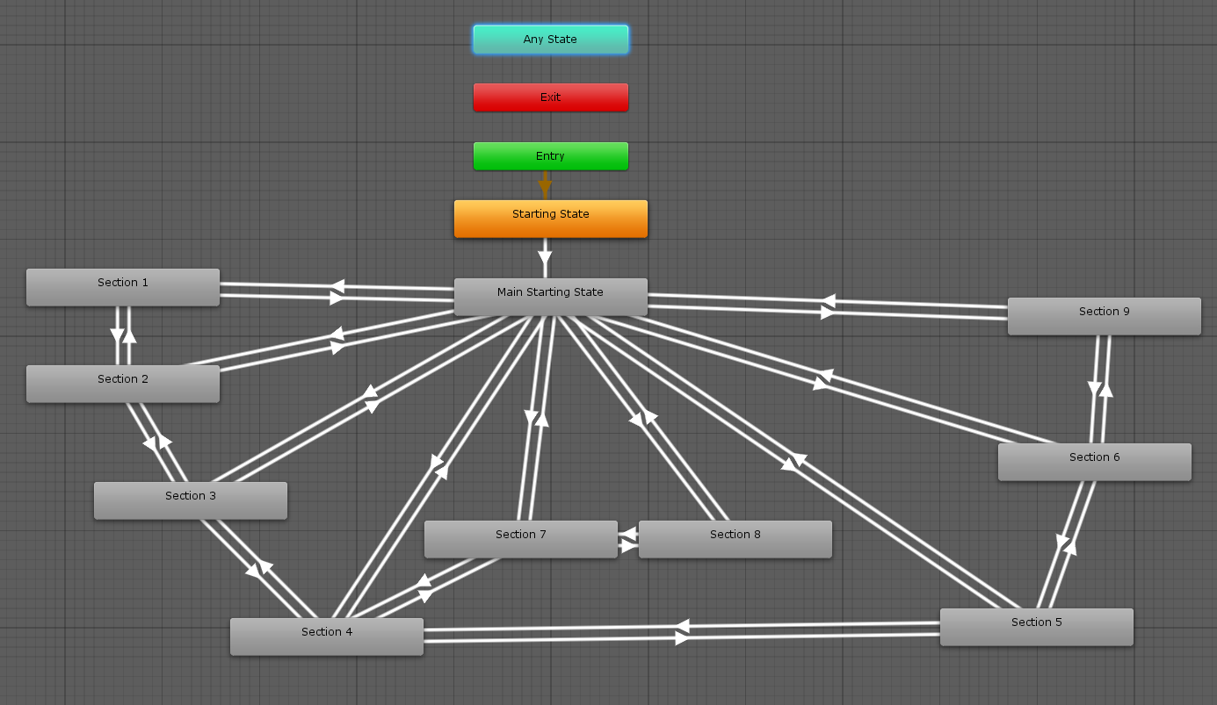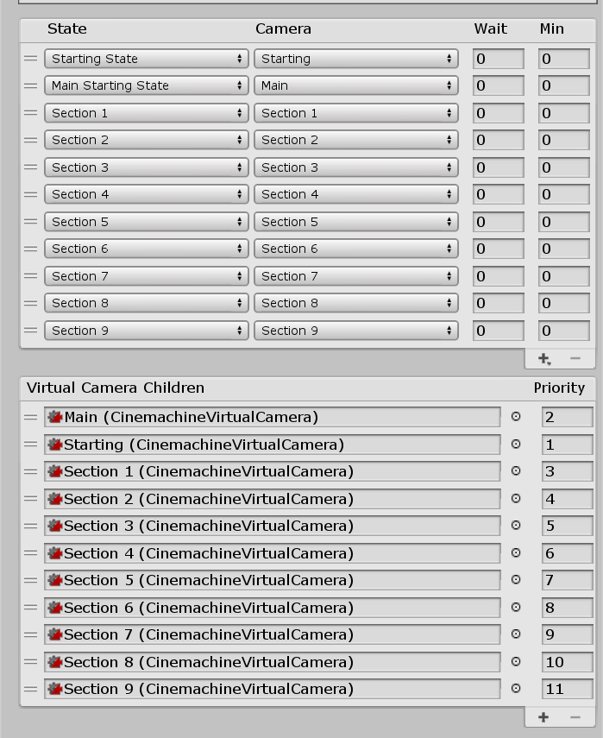

Troop Selection
In order to incorporate troop selection to eventually deploy individual units to a battle, a troop selection interface was implemented. Troop and ship information is retrieved from the database and used to instantiate player profile tiles. These tiles can be clicked to reveal individual statistics as well as to assign troops to individual ships

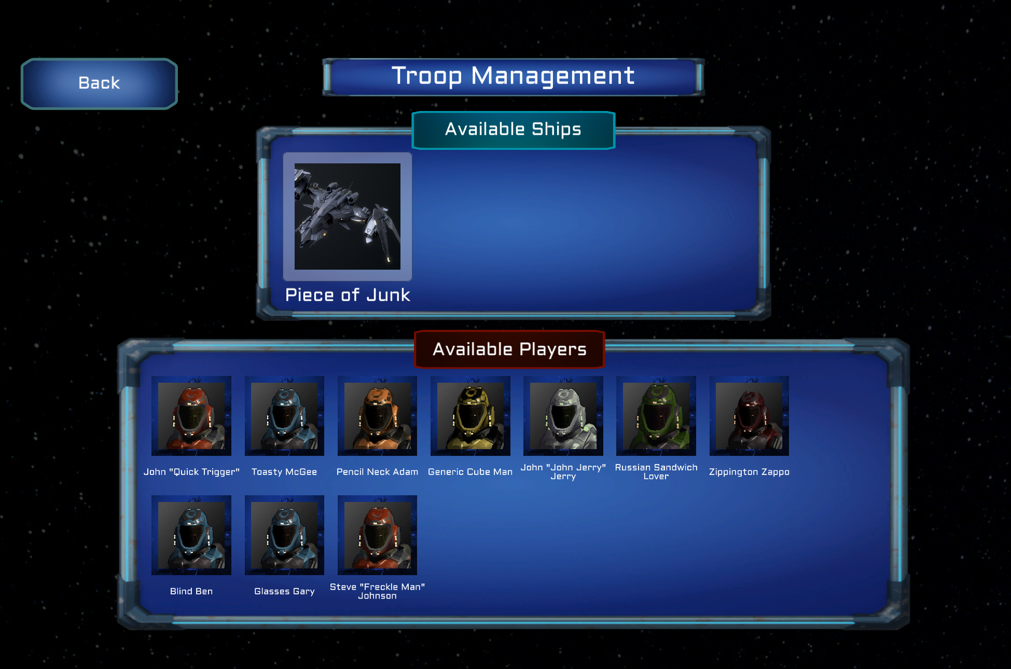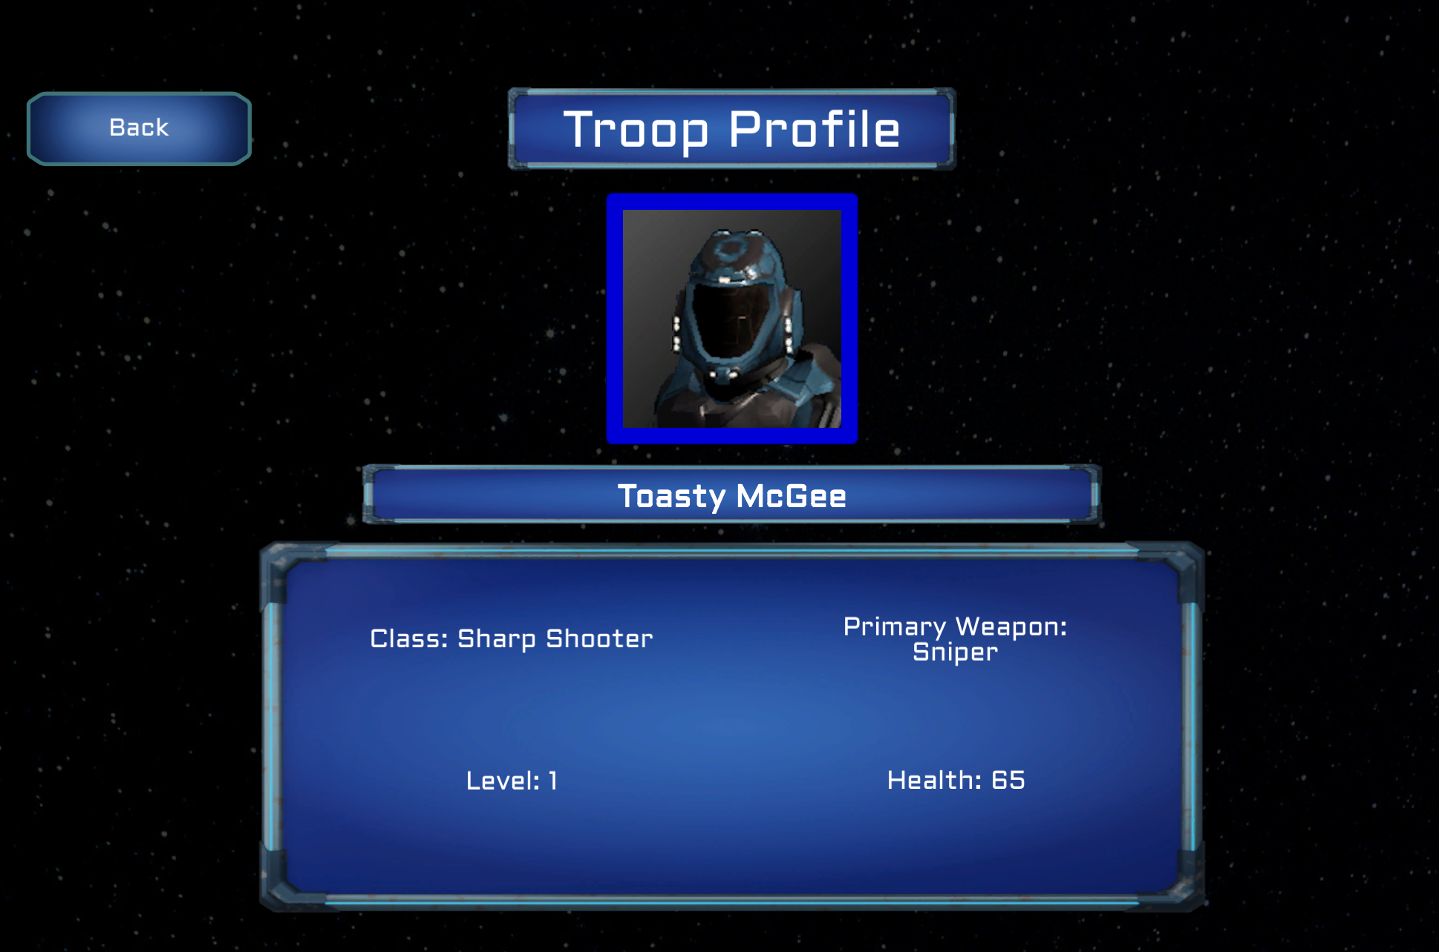

Ship Movement
Ships assigned with troops from the troop management interface can navigate to different planets by pressing enter when the appropriate edge is highlighted. The contested planet that the ship reaches then expands into view and the battle start interface appears.

Ground Battle

Procedural Content Generation
On entering the battle scene, a procedural content generation algorithm is passed a variety of parameters with which to configure the randomly generated map. These parameters include the number of enemies to instantiate, which player characters to place, the overall size of the map, and the biome type. The algorithm places obstacles on the grid tile framework while ensuring that there exists a playable path between players and enemies. The level loading framework places down the correct assets as well as retrieving the proper information saved in the local database.

Grid Based Combat
The battle scene consists of a grid framework on which obstacles, player characters, enemies, and open space can exist. Each of these potential states is characterized by a tile type, namely hazard tiles, player tiles, enemy tiles, and open tiles respectively. The pcg algorithm configures the placement of these tile types and then instantiates the correct Unity prefabs where appropriate.

Movement
Player and enemy characters are able to move across open space tiles in a path consisting of forward, backward, left, or right movements. Upon selecting a player character, a path indicator will indicate all the potential paths available provided the player has a move turn available.

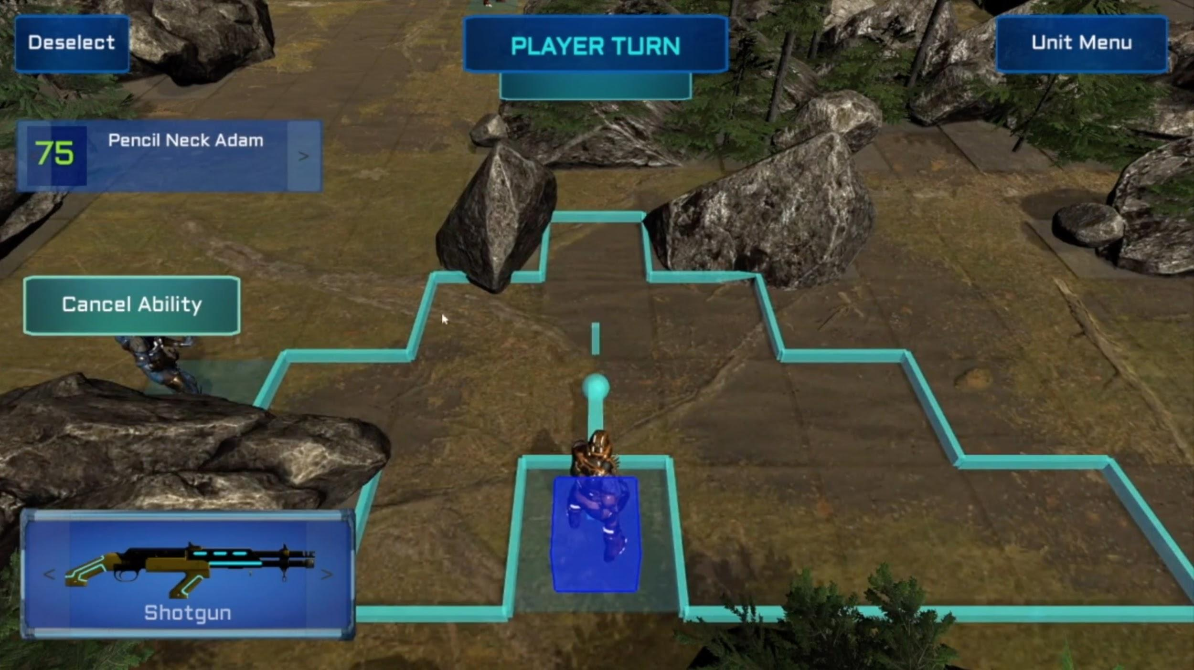

Combat
The combat system in our game consists of turn based gameplay in which every player character has the option to move and attack, or forfeit their turn. Once the player’s turn is over, the AI proceeds to move and attack the user’s characters.

Abilities
Each character can use one ability per battle. Characters have different abilities, with each class having its own. Abilities are all created by implementing an interface and are typically called by pressing the Ability button (There is one passive ability where there is no need to press the button). Ingame, information about the abilities can be found in the Unit Menu under the Ability tab for each character. The abilities are as follows:

Dash
Pressing the Ability button gives you an extra movement during that turn.
Double Attack
Pressing the Ability button gives you an extra attack during that turn.
Deployable Cover
After pressing the Ability button, clicking on any open tile will place an object that lasts for 3 turns. The object cannot be shot through or moved through. It will destroy itself after the player’s third turn.
Med Pack
After the Ability button is clicked, clicking on another player unit will heal up to 30 Health, but not over that character’s maximum Health.
Teleport
After the Ability button is clicked, clicking on an open tile will teleport the character to that tile.
Headshot
After the Ability button is clicked, clicking on an enemy in the attack range of the current weapon, and not blocked by any object will bring up the Attack Preview screen. This ability grants extra damage, at a lower accuracy. Pressing Headshot! will trigger this ability attack.
Defy Death (Passive Ability)
When the character drops to 0 Health, it will restore to ¼ of Maximum Health to continue on fighting. No action needs to be taken by the player to click this ability.

Art and Assets

Procedural Shaders

All the planets in the game use procedural textures. Within Unity, this meant creating an .hlsl shader. We opted for creating our own shader from scratch, as opposed to the render pipelines that Unity provided, since they required conversion of all our assets to work with a chosen pipeline.

Our shader provides the ability for an end user of the shader to choose between five noise types: 1D Perlin, 2D Perlin, 3D Perlin, fDm 3D and Nested fDm 3D. Additionally, seed, frequency, height, contrast, lacunarity and persistence are all tunable parameters. To color the planets, a color gradient image is input into the shader.

For fBm (fractal Brownian motion), there are additional parameters for tuning fBm type (standard, turbulence, ridge), octaves, as well as nested octaves. For nested octaves, it just means that the output of a fBm calculation is input into another fBm shader according to the following formula, where p is position:
nested_fBm(p) = fBm ( p + fBm( ... + fBm( p + fBm(p))...))

